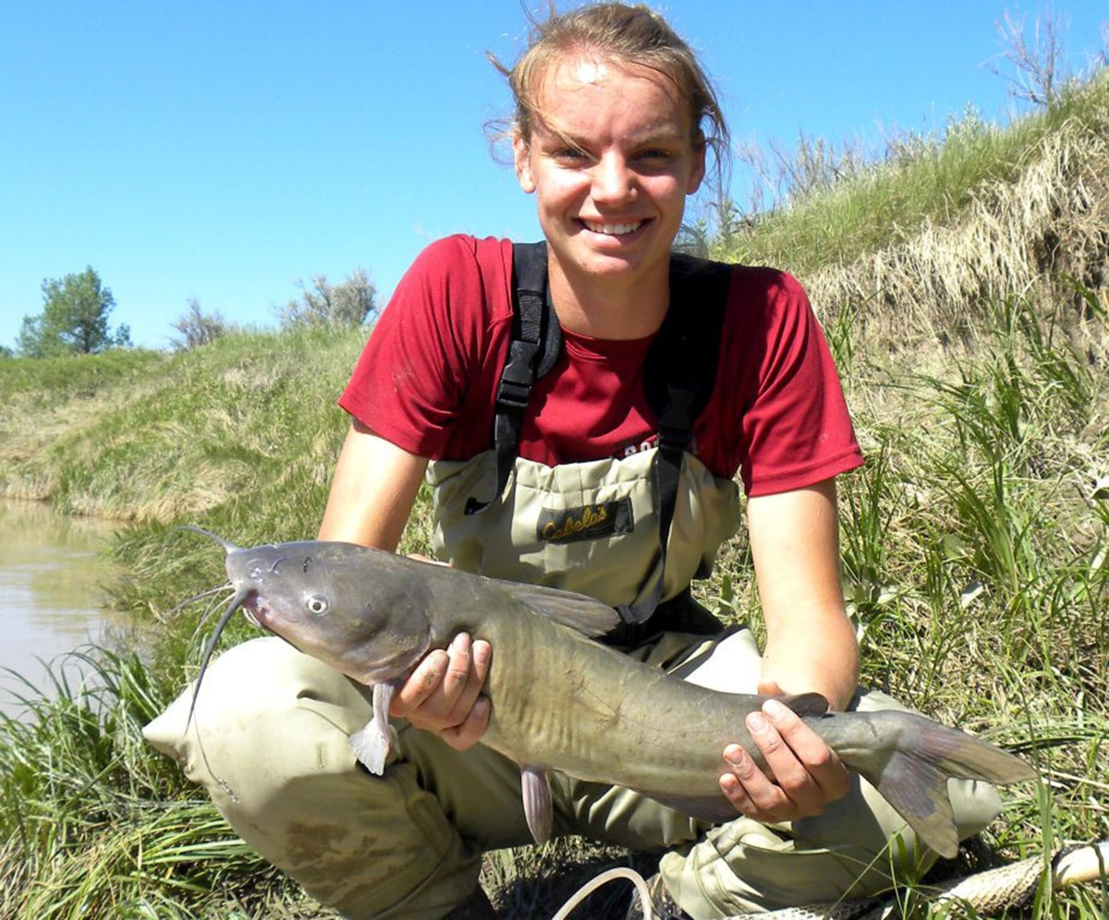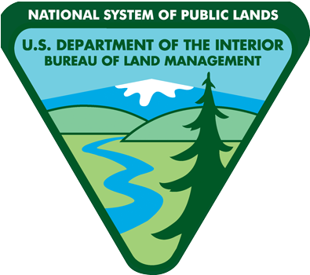
BLM employs local Hutton fisheries scholarship recipient
Mark E. Jacobsen, Public Affairs Specialist, Eastern Montana/Dakotas District

MILES CITY, Mont. – The BLM Miles City fisheries program in eastern Montana got some help this summer with the placement of a Hutton Program scholar, a volunteer field position funded by the American Fisheries Society.
Kadie Heinle, 2015 graduate of Custer County District High School and who has an interest in marine biology, was one of about 25 students selected from around the nation.
“The Hutton Program is for high school students interested in getting into the fisheries field,” said BLM Fish Biologist Christina Stuart. “It’s a great program and an honor for the student to be selected by AFS for this.”
According to the AFS, “the principle goal of the Hutton Program is to stimulate interest in pursuing fisheries science and aquatic resources management careers among high school students from groups
underrepresented in the fisheries professions including minorities and women.” Application is open to 11th and 12th grade students with preference to qualified women and minority applicants.
The AFS provides most everything for the student, including liability coverage. The student also gets a $3,000 scholarship. Hutton Scholars are required to work with a professional fish biologist for at least 40 hours per week for eight weeks, said Stuart.
According to Hutton Program specifics, the scholars are matched with a fisheries professional for “an exciting, hands-on summer internship in a marine or freshwater setting.”

“All parties benefit from the Hutton Program. The student receives a scholarship, a mentor, and beneficial field experience and the agency gets a volunteer which is invaluable help in completing the summer workload.” said Stuart. “Kadie is a remarkable person; I really enjoyed mentoring her and was grateful to have the extra help.”
A fisheries biologist serves as a program mentor and an application must be made by an agency professional on the receiving end. Once the mentor application is approved, the process moves forward and a Hutton Scholar can be placed.
This summer has been a busy one for both Stuart and Heinle. Prairie stream sampling, habitat monitoring, and data collection on BLM waterways have kept them active afield. At the end of the season, Heinle departs to the University of Montana in Missoula.
August 24, 2015

Kadie Heinle, 2015 graduate from Custer County District High School and a Hutton Program Scholar, worked this summer with the BLM Miles City Field Office performing fisheries work on BLM waterways in eastern Montana. Her field position was paid for by the American Fisheries Society.

“Participating in the Hutton Program was a great experience. I was able to try out a lot of different equipment throughout the varying jobs we did. I learned so much in just two months,” said Heinle. I would definitely recommend
this program to other high school students interested in fisheries because it’s awesome to gain this much real-world experience, all before you’ve even started your first day of college.”
Wendy Warren, BLM Assistant Field Manager for Renewable Resources in Miles City also found the program to be an asset to the BLM’s mission.
“This is the first year that the Miles City Field Office has participated in the Hutton Program,” said Warren. “I was very honored and excited that Kadie and the BLM’s application were matched for this summer.”
“The success of this program relies on the workload and the dedication to get it accomplished. I am pleased with the results and I’m proud to have had such an incredible person work with,” said Warren.
The Robert F. Hutton Endowment Fund was created in 2000 to receive contributions to support the program. The
fund’s namesake, the late Dr. Robert F. Hutton, served as the American Fisheries Society’s first Executive Director from 1965 to 1972 and the society President from 1976 to 1977.

